**David Hilliard Analysis: Widow**

by: Laiba Fatima Khan

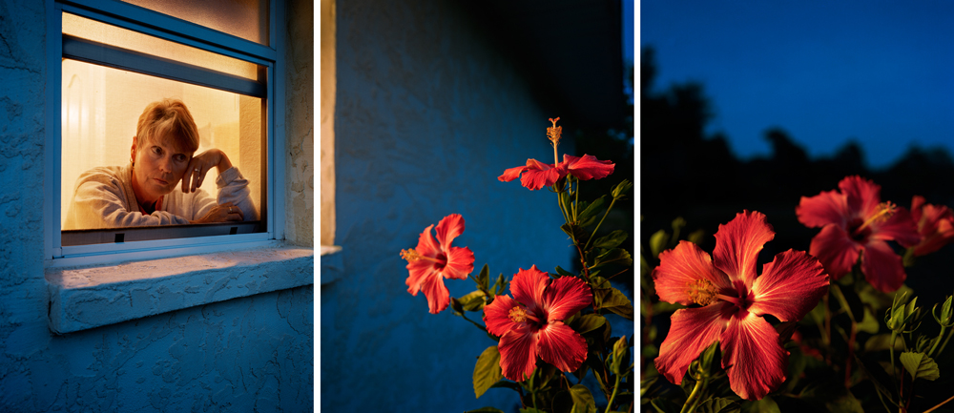

Looking at this photo, the first thing I saw is a middle-aged, blonde, white woman, looking out of her window. It seems to be late-evening or night, as the lights inside her room are on, and the sky outside is dark. Something is shining on her left hand that she is resting her face on, so I looked closer. It’s a wedding band on her ring-finger, which tells us that she is a married woman. But the lady seems to be alone in her room, staring at the flowers outside her window, lost in her thoughts, as if waiting for some loved one who promised to come back but haven’t yet.

David uses lighting and composition very beautifully, to convey the story. The lonely woman, who is the subject here, catches viewer’s attention first, since the window acts like a beautiful frame around her. The inside of the room is well-lit and brighter compared to the other parts of the photo, which also plays a part in catching out eyes. The woman’s eyes then lead us to the beautiful full-bloomed flowers, the other subject, outside her room. The blurred trees in the background of flowers, and the room door and intersection of walls behind the woman, add to the depth of field. The flowers and the woman both are lit from top-left.

This photo tells us the sad story of a lonely widow, who stares outside her window at night, missing her lost partner and waiting for them. The woman looks at the flowers blankly, flowers in full bloom; totally opposite of the world inside her. The difference of the world inside and outside her room, the liveliness and colorfulness of flowers, emphasize the lonely and dark world of the woman. This enhances the impact of the story even more, making the viewer feel the sadness of the lonely widow.